The Big One

Design Doc

# Table of Contents

Contents

Table of Contents 1

Detailed Game Description 2

Controls Description 2

Screen Descriptions 3

Start State 3

Gameplay State 4

End State 4

Enemies 4

Scoring 4

Sound Index 5

Art / Multimedia Index 6

Asteroid / Player 6

Mass Pickup 6

Sprites/masspickup.png 6

Background 6

Missile / Enemy 6

Missile Propulsion 6

# Detailed Game Description

In *The Big One* the player assumes the role of an asteroid trying to collect enough mass to destroy the Earth. You start as a very small but quick moving rock and collect “magic mass particles” while dodging the Earth’s defenses (missiles). The more mass you collect, the bigger and slower the player’s sprite becomes. To further hinder the player, the number of missiles is slowly increased to a maximum count of 5 missiles. On mass pickup, a player’s size is doubled. When hit by a missile, mass is halved. The game continues until the player is 5x their original mass (win) or become less than their initial mass (loss).

# Controls Description

Controls are simple WASD or arrow keys for movement. Movement speed is directly proportional to player score/mass.

# Screen Descriptions

### Start State

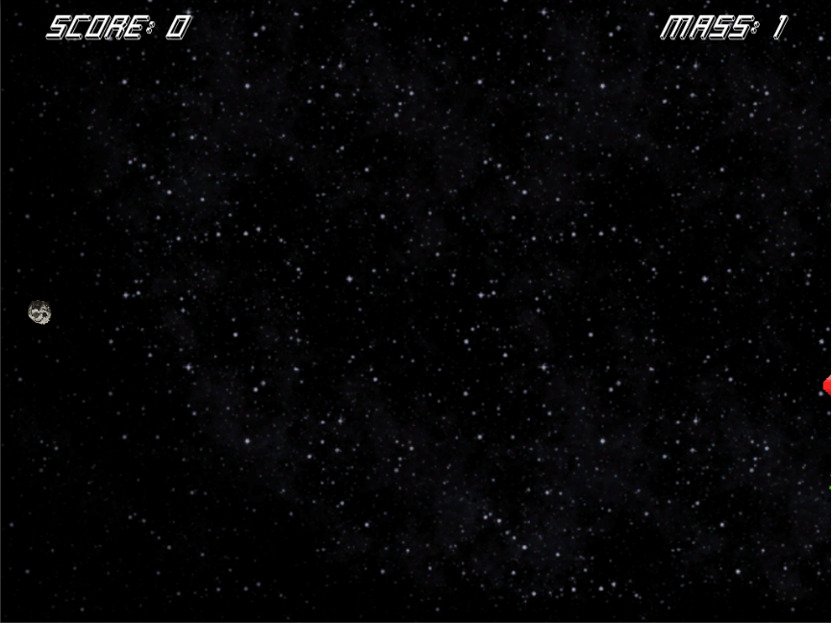

### Gameplay State

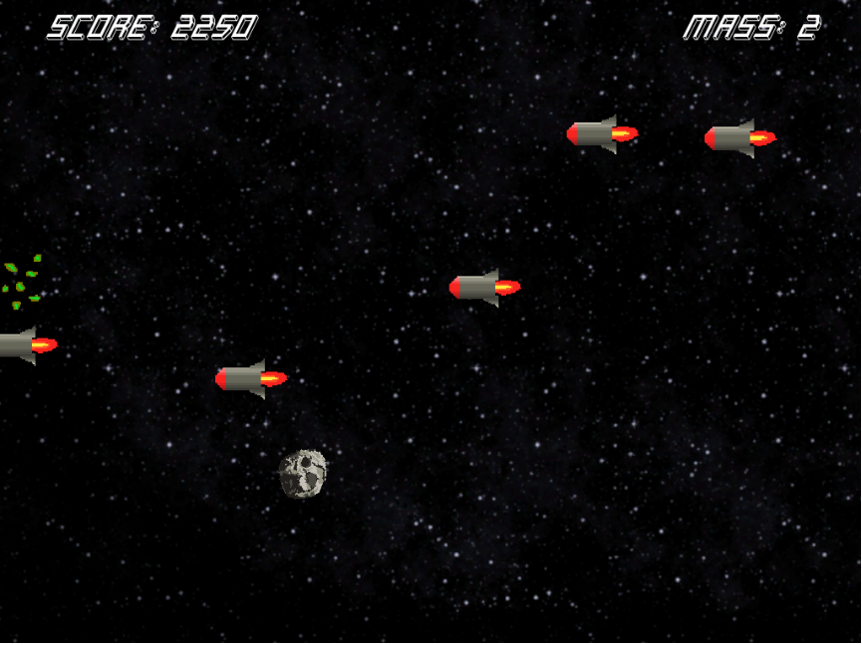

### End State

# Enemies

Enemy units in this game are missiles that scroll across the screen horizontally with random vertical movement variations. The player starts the game only facing one missile and a coroutine was written to slowly add more as the game progresses with a maximum of 5 enemies spawned at any given time. On collision, the players mass is halved and their score is reduced by one. A player loses once there health/mass hits 0.

# Scoring

A player gains 50 points for each enemy that scrolls past the end of the screen (left). The longer the player plays, the quicker their score may add up since there are more missiles.

# Sound Index

All audio assets are nested under the Audio asset folder.

Music – Music/TheBigOneBGM.mp3

Pickup / Enemy Hit – Pickups/hollow_thud.wav

Pickup Collected / Mass Gain – Pickups/mass_up.wav

Enemy Hit / Mass Loss – Pickups/wass_down.wav

# Art / Multimedia Index

|  |  |  |
| --- | --- | --- |
| Asteroid / PlayerSprites/asteroid.png | Mass Pickup Sprites/masspickup.png | Background Textures/starry-bg.png |
| Missile / Enemy Sprites/Missile/Missle.png | Missile PropulsionSprites/Missile/Propulsion1.pngPropulsion2.png Propulsion3.png |